Summary of questions
- When units only show for main category, ex. discharge but not runoff, I give full points✅
- Award a 0 to location columns that only have lat long and TRS ✅
- When TRS has a typo in location column, accompanied by location description, give full points - ⛔Award half points, still technically incorrect
- When TRS has a typo in TRS column, give half points ✅
- When TRS doesn’t include NE/SE/NW/SW, give half points ✅
- Gave 0 as the total score for index pages and paragraphs that were recognized and analyzed as tables ✅

Non-Tables Registered
- ID 2248 Page 291- (13 rows) Index Page
- ID 3174 Page 32- (7 rows)Works Cited
- ID 28057 Page 10- (5 rows) Index Page
- ID 56363 Page 15- (36 rows) Index Page
- Total of 61 rows given a zero
  - Overall accuracy with non-table scores 0.686
  - Overall accuracy without non-table scores 0.872

New Questions
ID 70038392 Page 391
- Analyzed by LLM but page not available in PDF folder from zip
- Highlighted in green for now

Possible county written on page, but not on purpose
ID 593 Page 37
- “City of san diego” written on description
- Characterized as SD county
- Gave full points because it was on the page

ID 724 Page 501
- Same issue as before
- States “near san bernardino” characterized county as san bernadino
- Gave full points

Same for:
- ID 1139 Page 88
- ID 1305 page 128
- ID 1595 page 55
- ID 2060 Page 164
- ID 56416 Page 429 (2 rows)

ID 70038406 Page 213
- 6 rows recorded
- 6 tables on page
- County written on first table description, but characterized on all the rows
- Gave full points because it was on the page

ID 70038677 Page 457
- 8 rows for 8 different tables
- All have the same measurements, but LLM categorizes them differently
- Water quality is the most accurate
- Also categorizes discharge
- Gave both 1 for now

Resolved

ID 56394 Page 165- TRS typo in location column
- Gave SE4SW4 instead of SE1/4SW1/4 in location column
  - Awarded full points for now because was a minimal error compared to the amount of right information provided
  - ⛔Award half points, still technically incorrect

ID 251 page 413- TRS typo in TRS column
- In township column, gave ['T. 2 N., R. 7 E., NE1 sec. 5'] instead of ['T. 2 N., R. 7 E., NE1/4 sec. 5']
  - Awarded half points because it’s the actual township column ✅

ID 366 Page 211- Two rows for the same ID and page
- Data states 10/01/1915-09/30/1916 (row 1: LB_248)
  - Table states “ending in sept 1915”, so the date is 10/01/1914- 09/30/1915
  - Awarded 0 points✅
- Temporal resolution states “daily measurements” (row 2: LB_249)
  - Only dates recorded on the table are oct 27 and june 4
  - Awarded full points, since there are such little measurements these do not look to have a monthly pattern✅

ID 431 Page 229- same “for the year ending sept 1926” problem
- Date written as 10/01/1926-09/30/1927
  - Should be 10/01/1925-9/30/1926
  - Awarded zero points ✅
- Only gave units for discharge, awarded full points b/c it’s main category ✅

ID 431 Page 295
- Gave East Park Resevoir as water source
  - Actual water source is little stony creek, but east park revoir is referred in the description
  - Awarded half points ✅
- Location described as “Orland project of the United States Bureau of Reclamation”- city “Lodoga, Ca.” on the page
  - Awarded half point, because I think city name is most appropriate for location ✅
- Water type categorized as “Reservoir”- awarded 0 points because discharge is the broadest category: ⛔give this half points due to the reservoir being fed by the creek
- Row 2- said “daily and monthly” but second table is only monthly
  - Awarded .5
  - ⛔award full points because we don’t know if row 2 is referring to the 2nd table or not

ID 1305 page 128- Location typo
- Logged “4 1/2 miles…” as “412 miles east of San Bernardino, Southern California” for location column
  - Awarded half point for now ✅

ID 1312 Page 78
- Oil well logged as “groundwater” category
  - Gave a 0.5 because it is well information- thickness and depth✅
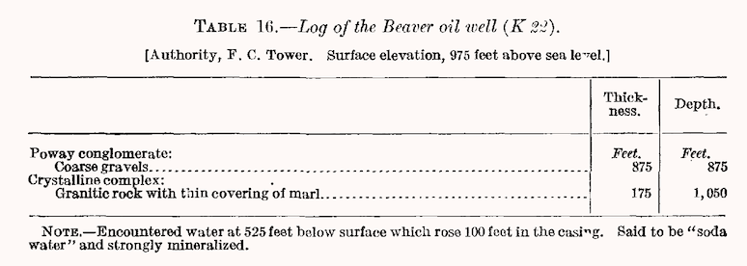

ID 1595 Page 55- Location and TRS typo
- Says “11 miles northeast of Highland, SW1 sec. 27, T. 1 N., R. 3 W.” for location
  - Supposed to be 1 ½ miles…, SW ¼
  - Awarded half points for both location and TRS ✅

ID 1595 Page 55
- Location- Water-stage recorder in W1 sec. 16, T. 8 S., R. 1 E.
  - Awarded a zero, basically only gave TRS, when “7 ½ miles south of San Jose and 4 miles southwest of Edenville” was written directly after✅
- TRS written as W1 instead of W ½
  - Awarded 0.5 ✅

ID 1606 Page 35
- Same typo with TRS ✅

ID 1610 Page 249
- Same typo with TRS ✅

ID 1627 Page 643
- Location only given as CA
  - City was on the page, awarded 0.5 ✅

ID 1640 Page 287
- Double check lat and long
- Looked relatively close but not on the dot
  - Awarded half a point
  - Actual location: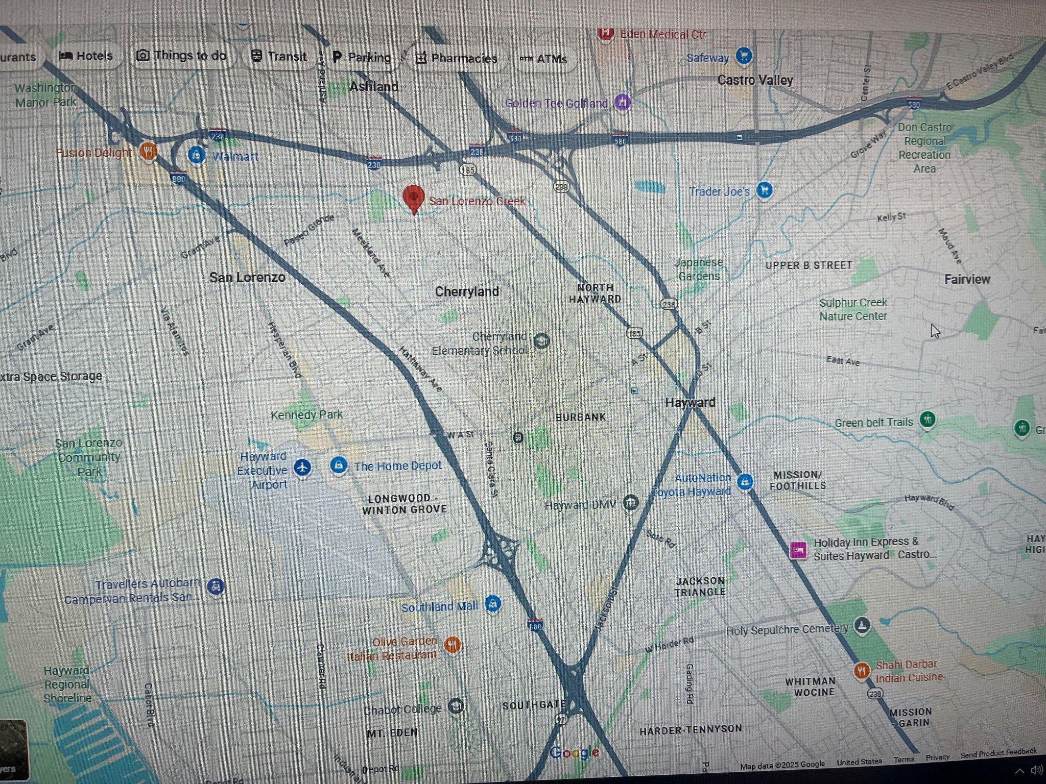
  - Lat/long: 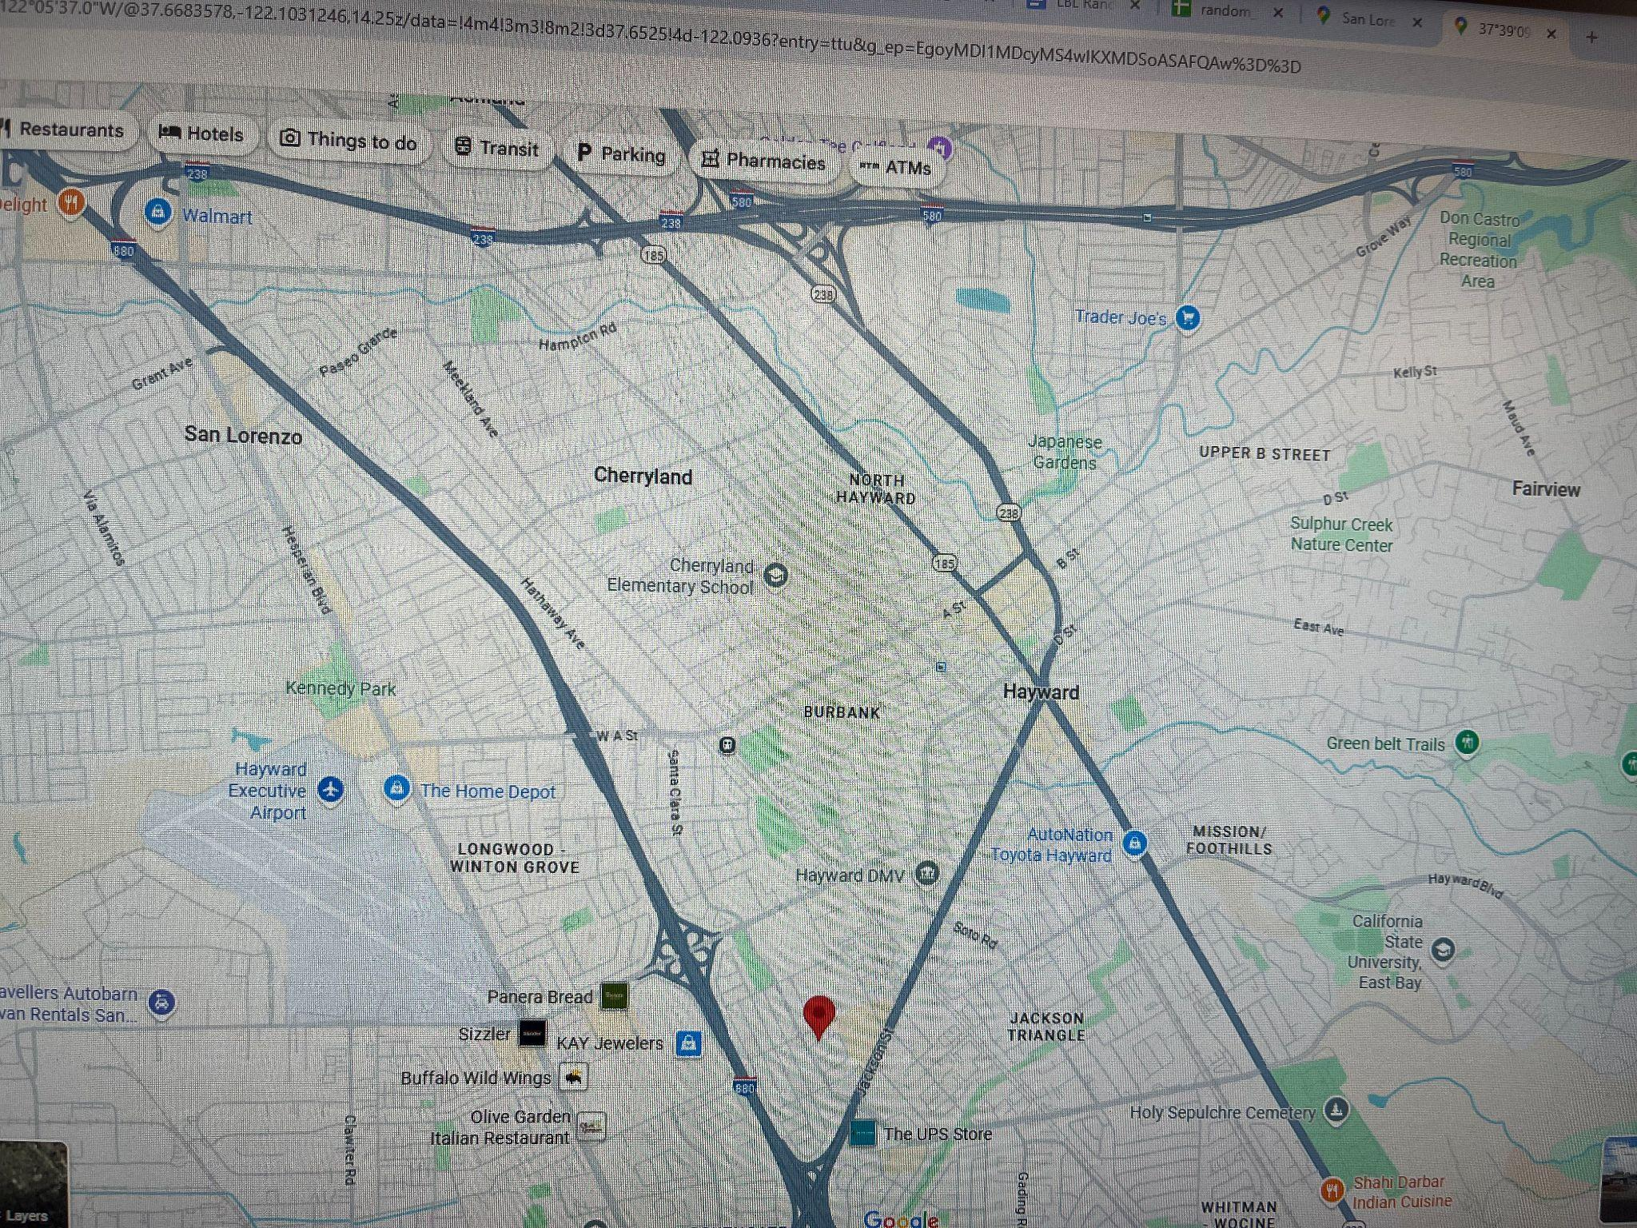

ID 1744 Page 49
- Gave TRS for the wrong table, the one on the next page
- No TRS available for table on this page
- Awarded full points because it was on the page ✅

ID 2060 Page 58- 16 rows for the same table
- Put well IDs as TRS
  - Awarded a 0 because format is different - ex. 11R1, 12C1, 12F1✅
- Put TRS as location
  - Awarded a 1 because this was the only location info available ✅
- Named watersource as owners
  - Awarded a 1 because this is how they’re distinguished on the page ✅
- Temporal resolution marked as “unknown:” when it looks like data was recorded only once
  - Awarded a 1 because it could not have gotten this information besides the fact that it was only logged once for each well ✅
- Categorized as groundwater
  - Awarded a 1 because category was “use of wells”; some being oil, irrigation, etc. ✅

ID 2246 page 545
- Lat and long were close to the river, but location was in a street
  - Awarded A 0.5
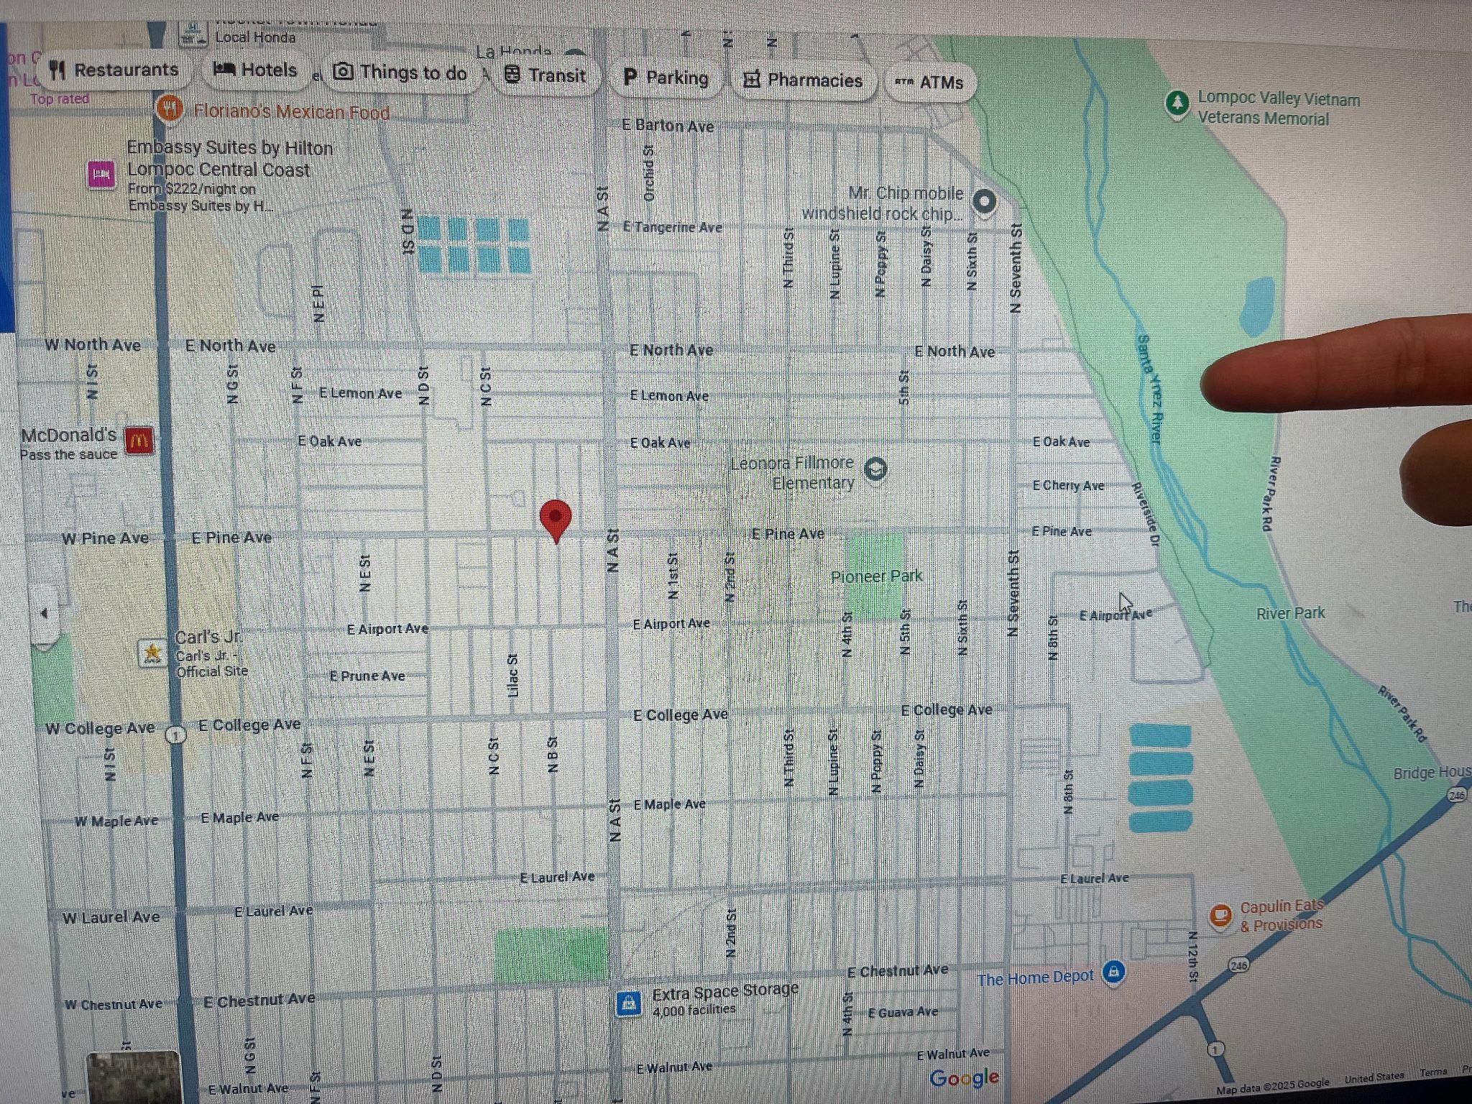

ID 2248 Page 291
- 13 rows for index page- gave 0 to all
- ✅ make a note of this page so we can count how many docs made it through without tables

ID 2294 Page 265
- Gave TRS for all rows of the table separated by commas
  - Some numbers were wrong, so I awarded half a point
- No watersource named
  - Gave a 0.5 because it could’ve said “wells in fresno county” (from title) or well owner name ✅
- No temporal resolution
  - Gave a 0.5, but not completely sure if i should give full points- looks like one time measurements logged in different years

ID 3150 page 342
- Lat and long were close, but not exactly at the creek, gave half points
  - Lat/Long 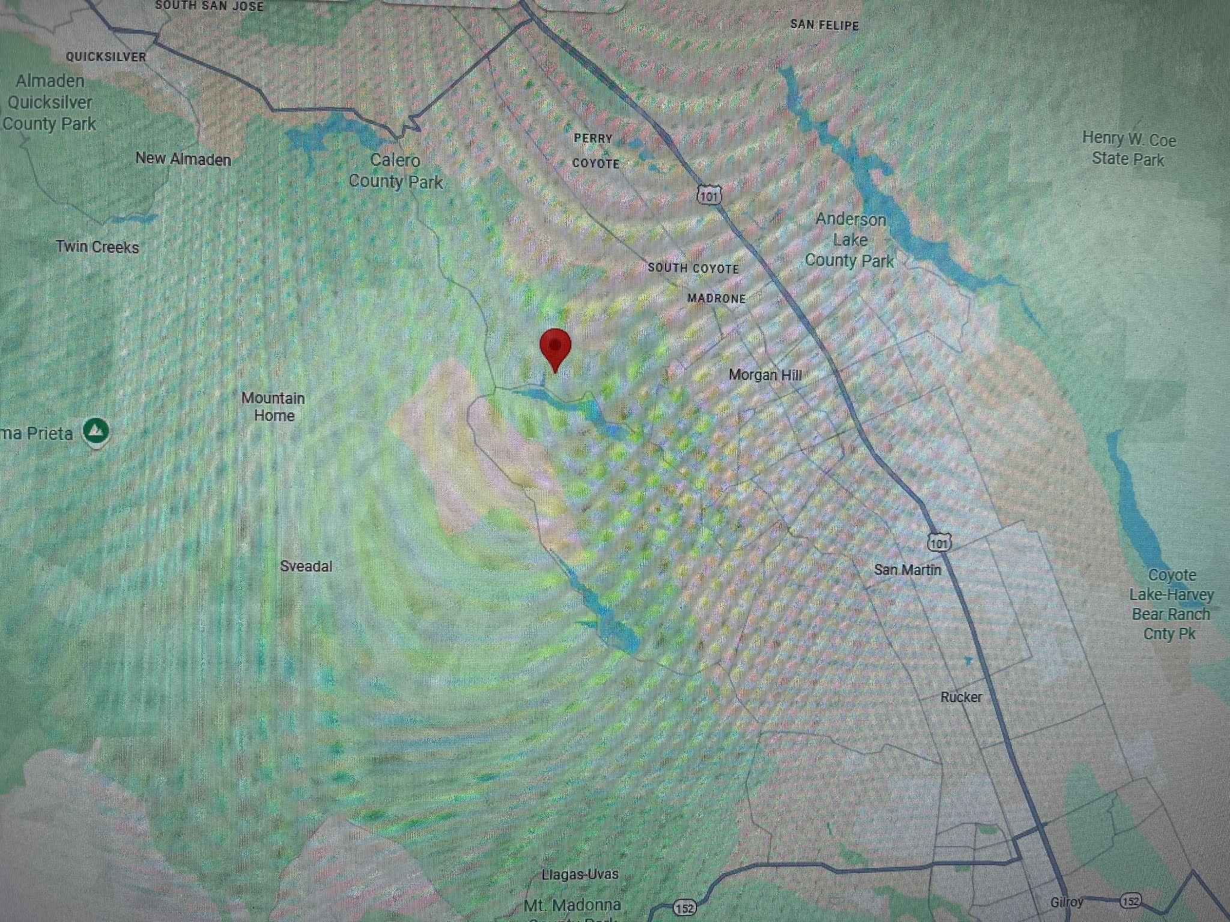
  - Creek Location: 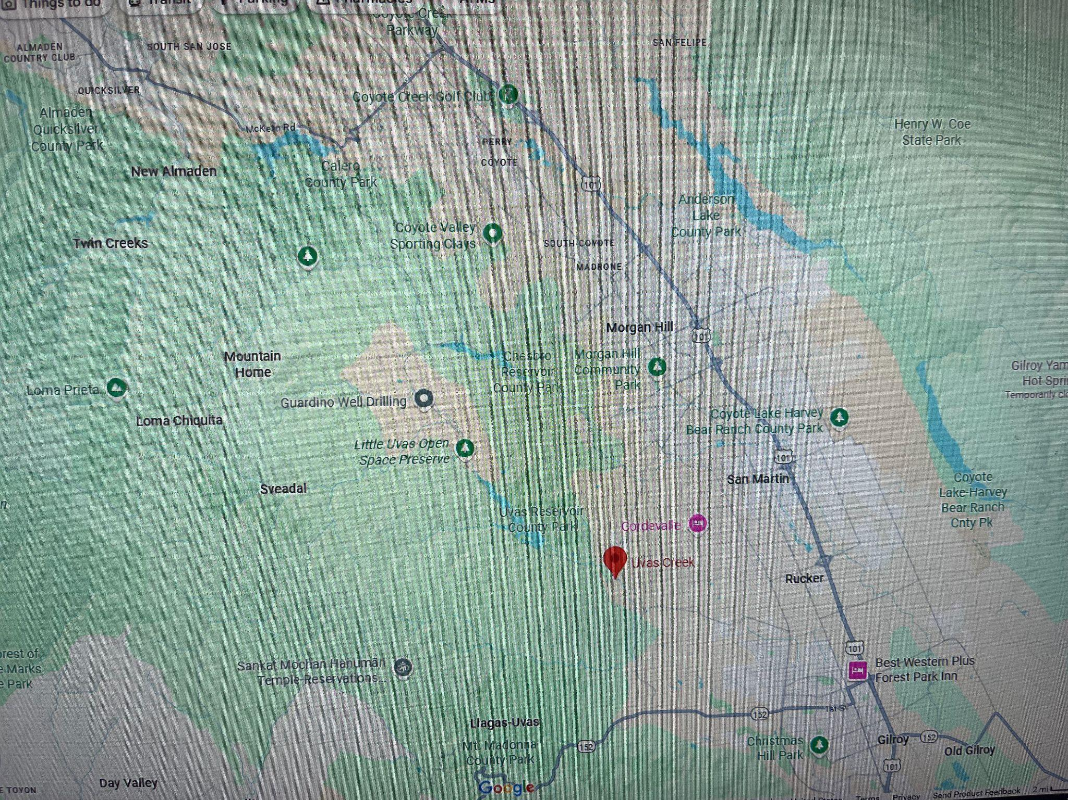

ID 3174 Page 32
- 7 rows for a page with no tables, read off a paragraph
  - Gave 0s ✅

ID 8375 Page 44
- No units written on page, but LLM gave units to all measurements
  - Gave standard units, so I awarded full points ✅

ID 24284 Page 136
- Data on discharge of well categorized by LLM as groundwater
  - Gave full points because that is technically the broader category ✅

ID 25073 Page 11
- No categories written on the table, but the LLM made up its categories and units
  - Gave a zero, not only units were guessed, but the entire table content itself ✅
- Categorized it as stream discharge when it was “quality of water of river”
  - Also gave a zero because we have a water quality category
  - Same for ID 56418 Page 262
  - ID 56418 page 563
  - ID 56502 Page 498
  - ID 56807 Page 53
  - ID 57549 Page 187
  - ID 57549 Page 611

ID 27847 Page 2
- Not technically a table, but table information included (it is a biographical data sheet)
  - Graded as if it was a table ✅

ID 28057 Page 10
- Index page, not table
- 5 rows for this same page
- Awarded 0 points ✅

